Computer architecture Lab Project

(Documentation)

Name : Niloy Chowdhury

Roll : 2107117

Group : B2

Course No : CSE 2114

Course Tittle : Computer Architecture Laboratory

Project Tittle : 24-bit CPU in Logisim

Submitted to :

Dr. M.M.A. Hashem Md. Badiuzzaman Shuvo

Professor Lecturer

Department of CSE. Department of CSE.

KUET KUET

Objectives:

1.To learn the core structure and working principle of a CPU.

2.To understand the implementation of control unit and ALU of a CPU.

3.To get insights about fetch and execution of a CPU.

4.To show a simple program containing various arithmetic and logical operations on 24-bit CPU.

Introduction:

In our project, we are trying to build a mini computer that can perform some basic operations to take some demonstrations how a computer actually functions in real life. This computer can do the following operations according to my bit:

1. LOAD : This instruction can load any data from specified location.This instruction has an opcode 6.
2. ADD : Adds the data of accumulator and a memory location. Finally saves the result in accumulator. This instruction’s opcode in 1.
3. Store : Stores the data of accumulator in a memory block of RAM.
4. SUB : Subtracts the data of accumulator by a memory location .Then stores the result in accumulator. This instruction’s opcode is 4.
5. Branch : Branches or Jump unconditionally. This instructions opcode is 5
6. HLT : Halts the processor.

New added Features:

I modified AND and OR operations to NAND and NOR operations.

NAND : NAND the result of each bit in accumulator and of a memory Block. It’s opcode is 0.

NOR : NOR the result of each bit in accumulator and of a memory Block. It’s opcode is 1.

Here is my final circuit with modified version according to my bits:

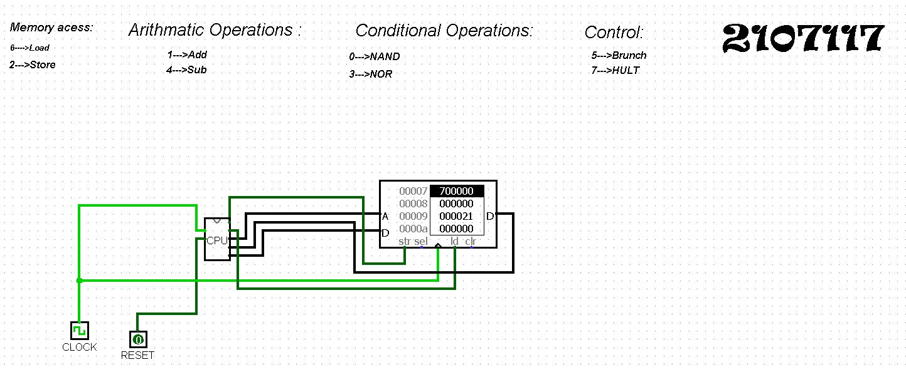

Small Program:

I primarily set the value 55 at memory location e and 33 at memory location f .

Instructions: Equivalent HEX:

LOAD 55 60000e

ADD 55,33 10000f

STORE 20000d

LOAD 88 60000d

SUB 55 40000b

STORE 20000c

LOAD 55 60000e

NOR 30000c

STORE 20000a

HLT 700000

Explanation:

Firstly the LOAD instruction loads the value 55 from location 0000e of the memory and stores the value in the accumulator. Then the ADD instruction adds the value 33 which is at the location f with the accumulator value and stores the result at accumulator. The next store instruction stores the result at location 0000d in the main memory .The LOAD instruction loads the value 88 from 0000d memory location and stores it in the accumulator. The next SUB instruction subtracts the value 55 which is at the location 0000b with the value which is currently in the accumulator. The result is stored in the location 0000c.Then the value in loaded from location 0000e in the accumulator.The NOR operation do the NOR between the value of accumulator and specified memory location of the instruction & stores the result at location 0000a. Finally the HULT instruction executes and the program stops.

NOTE : The Bits from 0 to 19 of the given instruction are the address bit and the Bits from 20 to 23 are the opcode bits which specify the operation to perform.

So,in HEX the MSB bit is opcode and other 5 bits are address bits.

Conclusion :

The design and implementation of a minimal computer system in logisim provided valuable insights into the inner working computer architecture. Through this project, I gained practical experiences in designing and integrating key components such as ALU, registers, Control unit, CPU as well as understanding their interconnections with their interactions. This project highlightened the importance of a systematic design approach, starting from basic building blocks and gradually expanding to more complex components. By simulating the operation of a computer system at the digital logic level, this project helped understanding concepts such as instruction fetch, execution, data manipulation and control flow.

Overall, this project served as an educational exercise in computer architecture equipping with foundational knowledge and practical skills essential for further exploration and study in the field of computer science and engineering.